**DBMS 2 – CS3563**

**Assignment 2 – Report**

***Group - 25***

* **Group Members:**
* Adhvik M – AI20BTECH11015
* Rahul Naga – A120BTECH11029
* Nikhil PG – CS20BTECH11036
* Suraj Telugu – CS20BTECH11050
* **How to Run Files to Obtain Database:**

1. Run “parser.cpp” to obtain the executable file, open the executable file to parse the “source.txt” file into the following .csv files.

Author_data.csv publication.csv Paper_data.csv

citation.csv Co_Author_data.csv

1. Run the below command in terminal at folder which contains “Paper_data.csv” to convert escape characters (\) into (\\) from “Paper_data.csv”. “Paper_details_data.csv” is now ready to populate.

**sed 's/\\/\\\\/g' Paper_data.csv > Paper_details_data.csv**

Note: Above command can be used only UNIX based systems like macOS or Linux for windows sed commands has to be downloaded externally.

1. Run “table.sql” in postgres to create tables (entities) as per the command below. The output will be obtained as shown below.

**\i <path which includes .csv files> table.sql**

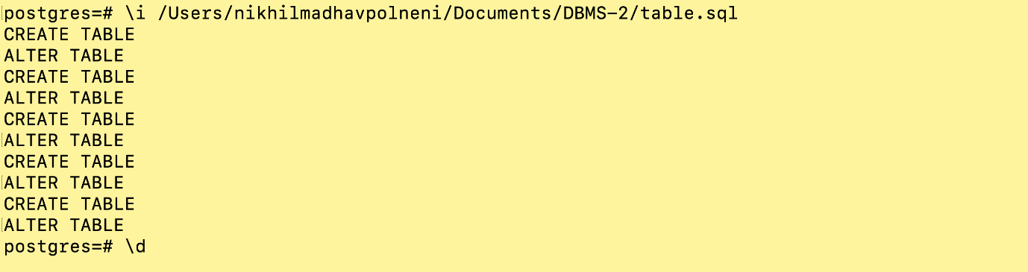

1. Change the paths of .csv files in “populate.sql”. Run “populate.sql” as per command below to populate the data in .csv files into the tables.

**\i <path which includes .csv files> populate.sql**

1. After running files as per above instructions, you should be able to see the output like below. The data base is successfully created in postgres.

